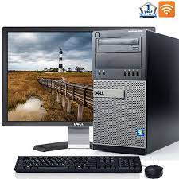

Dell Optiplex 390

* Intel Core I3
* DVD, USB Wifi
* Hard Drive 1 GB
* Screen 19" LCD
* **Rs.27,808**